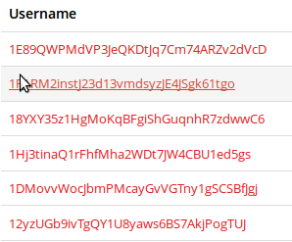


I would like an HTML page that takes the following data: http://p2pool.org:9332/web/graph_data/miner_hash_rates/last_day
Another data point
http://reassent.no-ip.biz:7777/web/graph_data/miner_hash_rates/last_day

The html page should have a list of miners from the data, an average for each miner based on the data, a small graph showing their rate.

The list should be similar to http://code.google.com/apis/ajax/playground/?type=visualization#stringfilter_control

The page should have paging: http://code.google.com/apis/ajax/playground/?type=visualization#table_paging

The graph should be a small graph of their hash like:
http://code.google.com/apis/ajax/playground/?type=visualization#image_line_chart

If I put it all together, it should look like this:

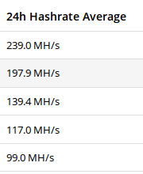
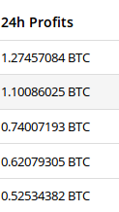

The 24 hour profits should come from a MySQL database. It should be combined with the rows here so that for the user, we can show the 24h profit.

The table is very simple, it is called [users] and contains the following columns:
user_id
24hour_profit

If you could write a quick script in PHP that will retrieve the 24 hour profit from the database. Or if you could provide a generic php program that retrievs json for a SQL query. There are many avaialble on google.

